As filed with the Securities and Exchange Commission on May 5, 2026

Registration No. 333-
UNITED STATES
SECURITIES AND EXCHANGE COMMISSION
Washington, D.C. 20549
FORM S-8
REGISTRATION STATEMENT
UNDER
THE SECURITIES ACT OF 1933
Rhythm Pharmaceuticals, Inc.
(Exact name of registrant as specified in its charter)
Delaware |  |  | 46-2159271
(State or other jurisdiction of incorporation or organization) |  |  | (I.R.S. Employer Identification No.)
222 Berkeley Street
12th Floor
Boston, MA 02116
(857) 264-4280
(Address of Principal Executive Offices) (Zip Code)
Rhythm Pharmaceuticals, Inc. Deferred Compensation Plan (Directors)
(Full title of the plan)
David P. Meeker, M.D.
Chief Executive Officer, President and Chairman of the Board
Rhythm Pharmaceuticals, Inc.
222 Berkeley Street
12th Floor
Boston, MA 02116
(857) 264-4280
(Name and address of agent for service) (Telephone number, including area code, of agent for service)
With copies to:
Peter N. Handrinos, Esq.
Latham & Watkins LLP
John Hancock Tower
200 Clarendon Street
Boston, MA 02116
(617) 948-6060
Indicate by check mark whether the registrant is a large accelerated filer, an accelerated filer, a non-accelerated filer, a smaller reporting company or an emerging growth company. See the definitions of “large accelerated filer,” “accelerated filer,” “smaller reporting company,” and “emerging growth company” in Rule 12b-2 of the Exchange Act.

Large accelerated filer x |  |  | Accelerated filer ☐
Non-accelerated filer ☐ |  |  | Smaller reporting company ☐
 |  |  | Emerging growth company ☐
If an emerging growth company, indicate by check mark if the registrant has elected not to use the extended transition period for complying with any new or revised financial accounting standards provided pursuant to Section 7(a)(2)(B) of Securities Act. ☐

EXPLANATORY NOTE
This Registration Statement on Form S-8 is being filed for the purpose of registering $1,500,000 of deferred compensation obligations of Rhythm Pharmaceuticals, Inc. (the “Registrant”) to pay deferred compensation in accordance with the terms of the Rhythm Pharmaceuticals, Inc. Deferred Compensation Plan (Directors) (the “Plan”). This Registration Statement registers cash-settled deferred compensation obligations of the Registrant under the Plan. Shares of the Registrant’s common stock deliverable in respect of deferred performance share units and restricted stock units were previously registered.

PART I
INFORMATION REQUIRED IN THE SECTION 10(a) PROSPECTUS
The information called for in Part I of Form S-8 is not being filed with or included in this Registration Statement (by incorporation by reference or otherwise) in accordance with the rules and regulations of the Securities and Exchange Commission (the “Commission”).

PART II
INFORMATION REQUIRED IN THE REGISTRATION STATEMENT

Item 3. Incorporation of Documents by Reference.
The following documents filed with the Commission (in each case, (File No. 001-38223) are hereby incorporated by reference in this Registration Statement:
(a) The Registrant’s Annual Report on Form 10-K for the year ended December 31, 2025, filed with the Commission on February 26, 2026;
(b) The Registrant’s Quarterly Report on Form 10-Q for the quarter ended March 31, 2026, filed with the Commission on May 5, 2026;
(c) The Registrant’s Current Reports on Form 8-K, filed with the Commission on January 9, 2026 (solely with respect to Item 8.01, March 2, 2026 (solely with respect to Item 8.01), March 16, 2026 (solely with respect to Item 8.01), March 20, 2026 (solely with respect to Item 8.01), March 26, 2026, (solely with respect to Item 8.01), April 3, 2026 (solely with respect to Item 5.02), and May 5, 2026 (solely with respect to Item 8.01); and
(d) The Registrant's Registration Statement on Form 8-A filed with the Commission on September 29, 2017 pursuant to Section 12(b) of the Securities Act of 1933, as amended (the “Securities Act”), relating to the Registrant’s common stock, 0.001 par value per share, as updated by “Description of the Registrant’s Securities registered pursuant to Section 12 of the Securities Exchange Act of 1934” filed as Exhibit 4.3 to the Registrant’s Annual Report on Form 10-K for the fiscal year ended December 31, 2023, and any amendment or report filed for the purpose of updating such description.
All reports and other documents filed by the Registrant with the Commission pursuant to Sections 13(a), 13(c), 14 and 15(d) of the Securities Exchange Act of 1934, as amended (the “Exchange Act”) after the date hereof (except for any portions of the Registrant’s Current Reports on Form 8-K furnished pursuant to Item 2.02 and/or Item 7.01 thereof and any corresponding exhibits thereto not filed with the Commission) and prior to the filing of a post-effective amendment to this

Registration Statement, which indicates that all securities offered hereby have been sold or which deregisters all securities then remaining unsold, shall be deemed to be incorporated by reference herein and to be a part hereof from the date of filing of such documents or reports.
Any statement contained in this Registration Statement, in an amendment hereto or in a document incorporated or deemed to be incorporated by reference herein shall be deemed to be modified or superseded for purposes of this Registration Statement to the extent that a statement contained herein or in any subsequently filed amendment to this Registration Statement or in any document that also is or is deemed to be incorporated by reference herein modifies or supersedes such statement. Any statement so modified or superseded shall not be deemed, except as so modified or superseded, to constitute a part of this Registration Statement, except as to specific portions of such statements as set forth therein.
Under no circumstances shall any information furnished under Item 2.02 and/or Item 7.01 of a Current Report on Form 8-K and any corresponding exhibits thereto be deemed incorporated herein by reference unless such Current Report on Form 8-K expressly provides to the contrary.

Item 4. Description of Securities.
The deferred compensation obligations (“Obligations”) being registered pursuant to the Plan represent obligations of the Registrant to pay deferred cash-based compensation in the future in accordance with the terms of the Plan, which is filed as an exhibit to this Registration Statement. Subject to the terms and conditions set forth in the Plan, eligible directors of the Registrant (“Participants”) are entitled to defer a portion of their annual cash retainer fees, restricted stock units and performance units, and such deferred amounts are credited to the Participant’s accounts under the Plan. The Obligations being registered relate solely to the Registrant’s obligation to pay deferred cash-based compensation (and not the restricted stock units and performance units).
The Obligations are general unsecured obligations of the Registrant subject to the claims of its general creditors. The Plan is considered entirely unfunded for tax purposes.
Under the Plan, cash-based compensation amounts credited to a Participant’s accounts are allocated to one or more deemed investment alternatives chosen by each Participant from a range of such alternatives available under the Plan. Each Participant’s accounts will be adjusted to reflect the notional investment performance of the selected investment alternative(s), including any appreciation or depreciation. The Obligations are payable in cash and generally will be paid in either a single lump-sum or in annual installments upon, as elected by the Participant, the Participant’s separation from service or a scheduled year. In the event of an unforeseeable financial hardship, the Participant may elect to receive some or all of the deferred amounts and related earnings, subject to approval by the administrator of the Plan.
A Participant may designate one or more beneficiaries to receive any portion of the Obligations payable in the event of death. Participants or beneficiaries may not anticipate, sell, transfer, assign, encumber or otherwise dispose of any right or interest in the Plan. The Registrant reserves the right to amend or terminate the Plan.

Item 5. Interests of Named Experts and Counsel.
Not applicable.

Item 6. Indemnification of Directors and Officers.
Section 145 of the Delaware General Corporation Law authorizes a corporation’s board of directors to grant, and authorizes a court to award, indemnity to officers, directors, employees, and other corporate agents.
As permitted by Delaware law, our amended and restated certificate of incorporation provides that, to the fullest extent permitted by Delaware law, no director will be personally liable to us or our stockholders for monetary damages for breach of fiduciary duty as a director. Pursuant to Delaware law such protection would be not available for liability:
•for any breach of a duty of loyalty to us or our stockholders;
•for acts or omissions not in good faith or which involve intentional misconduct or a knowing violation of law;
•for unlawful payments of dividends or unlawful stock repurchases or redemptions as provided in Section 174 of the Delaware General Corporation Law; or
•for any transactions from which the director derived an improper personal benefit.
Our amended and restated certificate of incorporation and amended and restated bylaws further provide that we must indemnify our directors and officers to the fullest extent authorized by applicable law. Our amended and restated bylaws also authorize us to indemnify any of our employees or agents and permit us to secure insurance on behalf of any officer,

director, employee or agent for any liability arising out of his or her action in that capacity, whether or not our amended and restated bylaws or Delaware law would otherwise permit indemnification.
In addition, our amended and restated bylaws also provide that we are required to advance expenses to our directors and officers as incurred in connection with legal proceedings against them for which they may be indemnified and that the rights conferred in the amended and restated bylaws are not exclusive.
We have entered into indemnification agreements with each of our directors and executive officers. These agreements, among other things, require us to indemnify each director and officer to the fullest extent permitted by Delaware law, our amended and restated certificate of incorporation and our amended and restated bylaws, for expenses such as, among other things, attorneys’ and experts’ fees, judgments, fines, penalties, and settlement amounts incurred by the director or executive officer in any action or proceeding, including any action by or in our right, arising out of the person’s services as our director or executive officer or as the director or executive officer of any subsidiary of ours or any other company or enterprise to which the person provides services at our request.

Item 7. Exemption from Registration Claimed.
Not applicable.

Item 8. Exhibits
Exhibit  Number |  |  |  |  |  | Description
4.1 |  |  |  |  |  | Amended and Restated Certificate of Incorporation of Rhythm Pharmaceuticals, Inc. and Certificate of Amendment (incorporated by reference to Exhibit 3.1 to Rhythm Pharmaceuticals, Inc.’s Current Report on Form 8-K (File No. 001-38223) filed on June 26, 2025)
4.2 |  |  |  |  |  | Amended and Restated Certificate of Designations of Rhythm Pharmaceuticals, Inc. (incorporated by reference to Exhibit 3.4 to Rhythm Pharmaceuticals, Inc.’s Quarterly Report on Form 10-Q (File No. 001 38223) filed on May 7, 2024)
4.3 |  |  |  |  |  | Amended and Restated Bylaws of Rhythm Pharmaceuticals, Inc. (incorporated by reference to Exhibit 3.1 to Rhythm Pharmaceuticals, Inc.’s Current Report on Form 8-K (File No. 001-38223) filed on December 18, 2023)
5.1* |  |  |  |  |  | Opinion of Latham & Watkins LLP
23.1* |  |  |  |  |  | Consent of Ernst & Young LLP, Independent Registered Public Accounting Firm
23.2* |  |  |  |  |  | Consent of Latham & Watkins LLP (included in Exhibit 5.1)
24.1* |  |  |  |  |  | Power of Attorney (included on signature page)
99.1 |  |  |  |  |  | Rhythm Pharmaceuticals, Inc. Deferred Compensation Plan (Directors) (incorporated by reference to Exhibit 10.1 to Rhythm Pharmaceuticals Inc.'s Quarterly Report on Form 10-Q (File No. 001-38223) filed on May 5, 2026)
107.1* |  |  |  |  |  | Filing Fee Table
* Filed herewith.

Item 9. Undertakings.
(a) The undersigned Registrant hereby undertakes:
(1) To file, during any period in which offers or sales are being made, a post-effective amendment to this Registration Statement:
(i) To include any prospectus required by Section 10(a)(3) of the Securities Act of 1933;
(ii) To reflect in the prospectus any facts or events arising after the effective date of the Registration Statement (or the most recent post-effective amendment thereof) which, individually or in the aggregate, represent a fundamental change in the information set forth in the Registration Statement. Notwithstanding the foregoing, any increase or decrease in volume of securities offered (if the total dollar value of securities offered would not exceed that which was registered) and any deviation from the low or high end of the estimated maximum offering range may be reflected in the form of prospectus filed with the Commission pursuant to Rule 424(b) if, in the aggregate, the changes in volume and price represent no more

than a 20% change in the maximum aggregate offering price set forth in the “Calculation of Filing Fee” table in the effective Registration Statement; and
(iii) To include any material information with respect to the plan of distribution not previously disclosed in the Registration Statement or any material change to such information in the Registration Statement;
provided, however, that paragraphs (a)(1)(i) and (a)(1)(ii) of this section do not apply if the Registration Statement is on Form S-8, and the information required to be included in a post-effective amendment by those paragraphs is contained in reports filed with or furnished to the Commission by the Registrant pursuant to Section 13 or Section 15(d) of the Securities Exchange Act of 1934 that are incorporated by reference in the Registration Statement;
(2) That, for the purpose of determining any liability under the Securities Act of 1933, each such post-effective amendment shall be deemed to be a new registration statement relating to the securities offered therein, and the offering of such securities at that time shall be deemed to be the initial bona fide offering thereof; and
(3) To remove from registration by means of a post-effective amendment any of the securities being registered which remain unsold at the termination of the offering.
(b) The undersigned Registrant hereby undertakes that, for purposes of determining any liability under the Securities Act of 1933, each filing of the Registrant’s annual report pursuant to Section 13(a) or Section 15(d) of the Securities Exchange Act of 1934 (and, where applicable, each filing of an employee benefit plan’s annual report pursuant to Section 15(d) of the Securities Exchange Act of 1934) that is incorporated by reference in the Registration Statement shall be deemed to be a new registration statement relating to the securities offered therein, and the offering of such securities at that time shall be deemed to be the initial bona fide offering thereof.
(c) Insofar as indemnification for liabilities arising under the Securities Act of 1933 may be permitted to directors, officers and controlling persons of the Registrant pursuant to the foregoing provisions, or otherwise, the Registrant has been advised that in the opinion of the Securities and Exchange Commission such indemnification is against public policy as expressed in the Act and is, therefore, unenforceable. In the event that a claim for indemnification against such liabilities (other than the payment by the Registrant of expenses incurred or paid by a director, officer or controlling person of the Registrant in the successful defense of any action, suit or proceeding) is asserted by such director, officer or controlling person in connection with the securities being registered, the Registrant will, unless in the opinion of its counsel the matter has been settled by controlling precedent, submit to a court of appropriate jurisdiction the question whether such indemnification by it is against public policy as expressed in the Act and will be governed by the final adjudication of such issue.

SIGNATURES
Pursuant to the requirements of the Securities Act of 1933, the registrant certifies that it has reasonable grounds to believe that it meets all of the requirements for filing on Form S-8 and has duly caused this registration statement to be signed on its behalf by the undersigned, thereunto duly authorized, in the City of Boston, Commonwealth of Massachusetts, on May 5, 2026.
RHYTHM PHARMACEUTICALS, INC.
By: |  |  | /s/ David P. Meeker, M.D.
 |  |  | David P. Meeker, M.D.
 |  |  | Chief Executive Officer, President and Chairman of the Board
POWER OF ATTORNEY
Each person whose signature appears below hereby constitutes and appoints David P. Meeker, M.D. and Hunter C. Smith, or each of them singly, with full power to act without the other, such person’s true and lawful attorneys-in-fact and agents, with full power of substitution and re-substitution, for him or her and in his or her name, place and stead, in any and all capacities, to sign this registration statement and any and all amendments, including post-effective amendments to this registration statement, and to file the same, with exhibits and schedules thereto, and other documents in connection therewith, with the Securities and Exchange Commission, granting unto said attorneys-in-fact and agents, and each of

them, full power and authority to do and perform each and every act and thing requisite and necessary or desirable to be done in connection therewith as fully to all intents and purposes as he might or could do in person, hereby ratifying and confirming all that said attorneys-in-fact and agents, or any of them, or their or his or her substitute or substitutes may lawfully do or cause to be done by virtue hereof.
Pursuant to the requirements of the Securities Act of 1933, this registration statement has been signed by the following persons in the capacities and on the date indicated.
Signature |  |  |  |  |  | Title |  |  |  |  |  | Date
/s/ David P. Meeker, M.D. |  |  |  |  |  | Chief Executive Officer, President and Director |  |  |  |  |  | May 5, 2026
David P. Meeker, M.D. |  |  |  |  |  | (Principal Executive Officer)
/s/ Hunter C. Smith |  |  |  |  |  | Chief Financial Officer |  |  |  |  |  | May 5, 2026
Hunter C. Smith |  |  |  |  |  | (Principal Financial Officer)
/s/ Christopher P. German |  |  |  |  |  | Corporate Controller |  |  |  |  |  | May 5, 2026
Christopher P. German |  |  |  |  |  | (Principal Accounting Officer)
/s/ Lynn A. Tetrault, J.D. |  |  |  |  |  | Lead Director |  |  |  |  |  | May 5, 2026
Lynn A. Tetrault, J.D.
/s/ Stuart Arbuckle |  |  |  |  |  | Director |  |  |  |  |  | May 5, 2026
Stuart Arbuckle
/s/ Jennifer L. Good |  |  |  |  |  | Director |  |  |  |  |  | May 5, 2026
Jennifer L. Good
/s/ Christophe R. Jean |  |  |  |  |  | Director |  |  |  |  |  | May 5, 2026
Christophe R. Jean
/s/ David W. J. McGirr |  |  |  |  |  | Director |  |  |  |  |  | May 5, 2026
David W. J. McGirr
/s/ Kimberly J. Popovits |  |  |  |  |  | Director |  |  |  |  |  | May 5, 2026
Kimberly J. Popovits

Calculation of Filing Fee Tables
S-8
RHYTHM PHARMACEUTICALS, INC.
Table 1: Newly Registered Securities
 | Security Type | Security Class Title | Fee Calculation Rule | Amount Registered | Proposed Maximum Offering Price Per Unit | Maximum Aggregate Offering Price | Fee Rate | Amount of Registration Fee
1 | Other | Deferred Compensation Obligations | Other | 1,500,000 | $ 1.00 | $ 1,500,000.00 | 0.0001381 | $ 207.15
Total Offering Amounts: |  |  |  |  |  | $ 1,500,000.00 |  | $ 207.15
Total Fee Offsets: |  |  |  |  |  |  |  | $ 0.00
Net Fee Due: |  |  |  |  |  |  |  | $ 207.15
Offering Note
1 | The deferred compensation obligations being registered are general unsecured obligations of Rhythm Pharmaceuticals, Inc. to pay deferred compensation in accordance with the terms of the Rhythm Pharmaceuticals, Inc. Deferred Compensation Plan (Directors) (the "Deferred Compensation Plan"). In accordance with Rule 416(a) under the Securities Act of 1933, as amended (the "Securities Act"), this registration statement shall be deemed to cover any additional securities that may from time to time be offered or issued under the Deferred Compensation Plan to prevent dilution resulting from stock splits, stock dividends or similar transactions. Estimated solely for the purpose of calculating the registration fee pursuant to Rule 457(h) of the Securities Act, based upon an estimate of the amount of compensation participants may defer under the Deferred Compensation Plan.
Table 2: Fee Offset Claims and Sources | ☑Not Applicable
 |  | Registrant or Filer Name | Form or Filing Type | File Number | Initial Filing Date | Filing Date | Fee Offset Claimed | Security Type Associated with Fee Offset Claimed | Security Title Associated with Fee Offset Claimed | Unsold Securities Associated with Fee Offset Claimed | Unsold Aggregate Offering Amount Associated with Fee Offset Claimed | Fee Paid with Fee Offset Source
Rule 457(p)
Fee Offset Claims
Fee Offset Sources
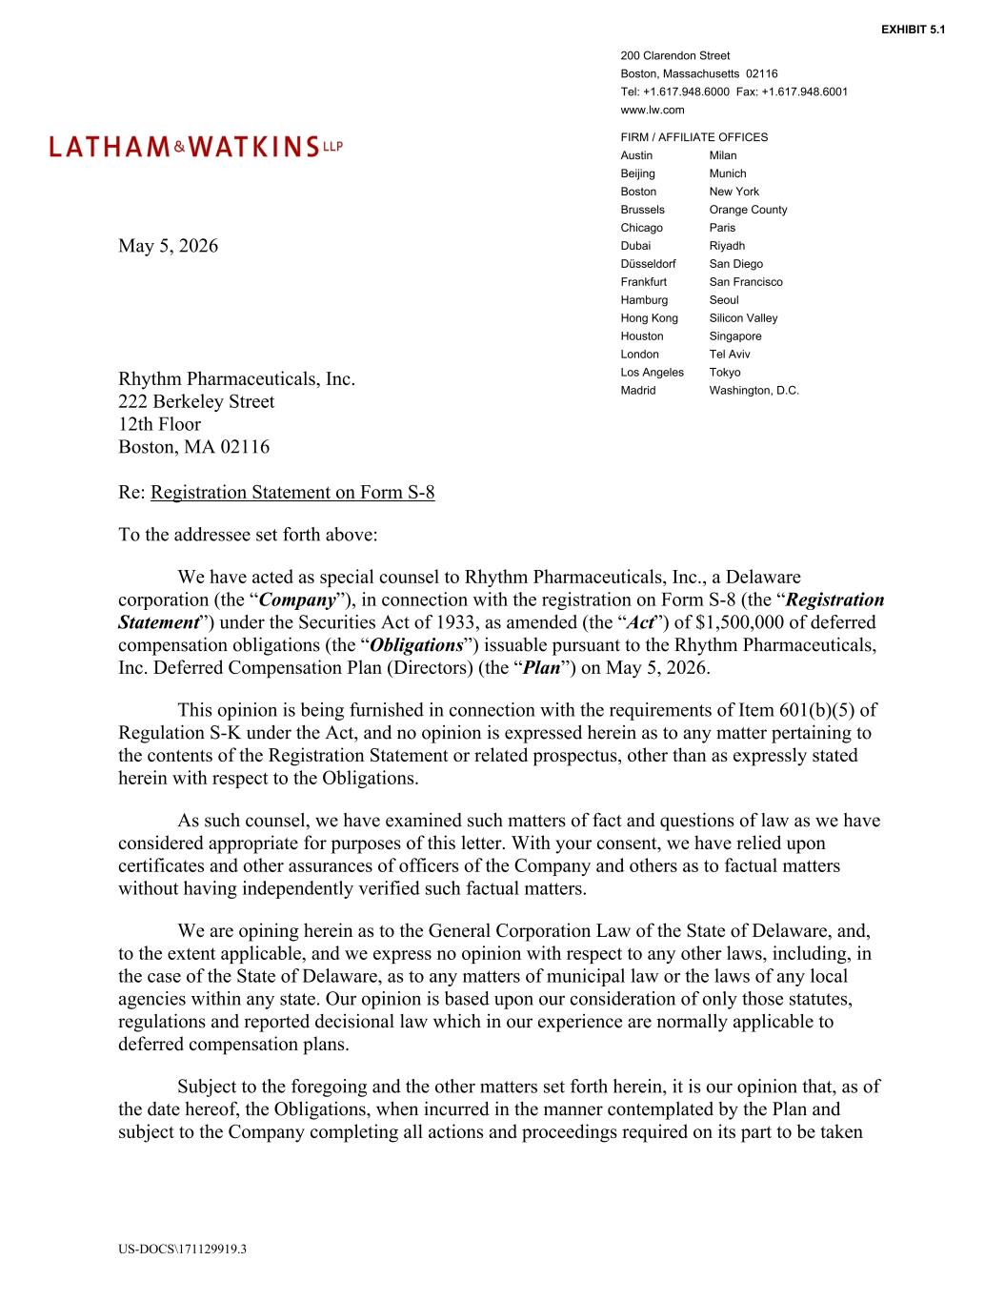
US-DOCS\171129919.3 200 Clarendon Street Boston, Massachusetts 02116 Tel: +1.617.948.6000 Fax: +1.617.948.6001 www.lw.com FIRM / AFFILIATE OFFICES Austin Milan Beijing Munich Boston New York Brussels Orange County Chicago Paris Dubai Riyadh Düsseldorf San Diego Frankfurt San Francisco Hamburg Seoul Hong Kong Silicon Valley Houston Singapore London Tel Aviv Los Angeles Tokyo Madrid Washington, D.C. May 5, 2026 Rhythm Pharmaceuticals, Inc. 222 Berkeley Street 12th Floor Boston, MA 02116 Re: Registration Statement on Form S-8 To the addressee set forth above: We have acted as special counsel to Rhythm Pharmaceuticals, Inc., a Delaware corporation (the “Company”), in connection with the registration on Form S-8 (the “Registration Statement”) under the Securities Act of 1933, as amended (the “Act”) of $1,500,000 of deferred compensation obligations (the “Obligations”) issuable pursuant to the Rhythm Pharmaceuticals, Inc. Deferred Compensation Plan (Directors) (the “Plan”) on May 5, 2026. This opinion is being furnished in connection with the requirements of Item 601(b)(5) of Regulation S-K under the Act, and no opinion is expressed herein as to any matter pertaining to the contents of the Registration Statement or related prospectus, other than as expressly stated herein with respect to the Obligations. As such counsel, we have examined such matters of fact and questions of law as we have considered appropriate for purposes of this letter. With your consent, we have relied upon certificates and other assurances of officers of the Company and others as to factual matters without having independently verified such factual matters. We are opining herein as to the General Corporation Law of the State of Delaware, and, to the extent applicable, and we express no opinion with respect to any other laws, including, in the case of the State of Delaware, as to any matters of municipal law or the laws of any local agencies within any state. Our opinion is based upon our consideration of only those statutes, regulations and reported decisional law which in our experience are normally applicable to deferred compensation plans. Subject to the foregoing and the other matters set forth herein, it is our opinion that, as of the date hereof, the Obligations, when incurred in the manner contemplated by the Plan and subject to the Company completing all actions and proceedings required on its part to be taken EXHIBIT 5.1

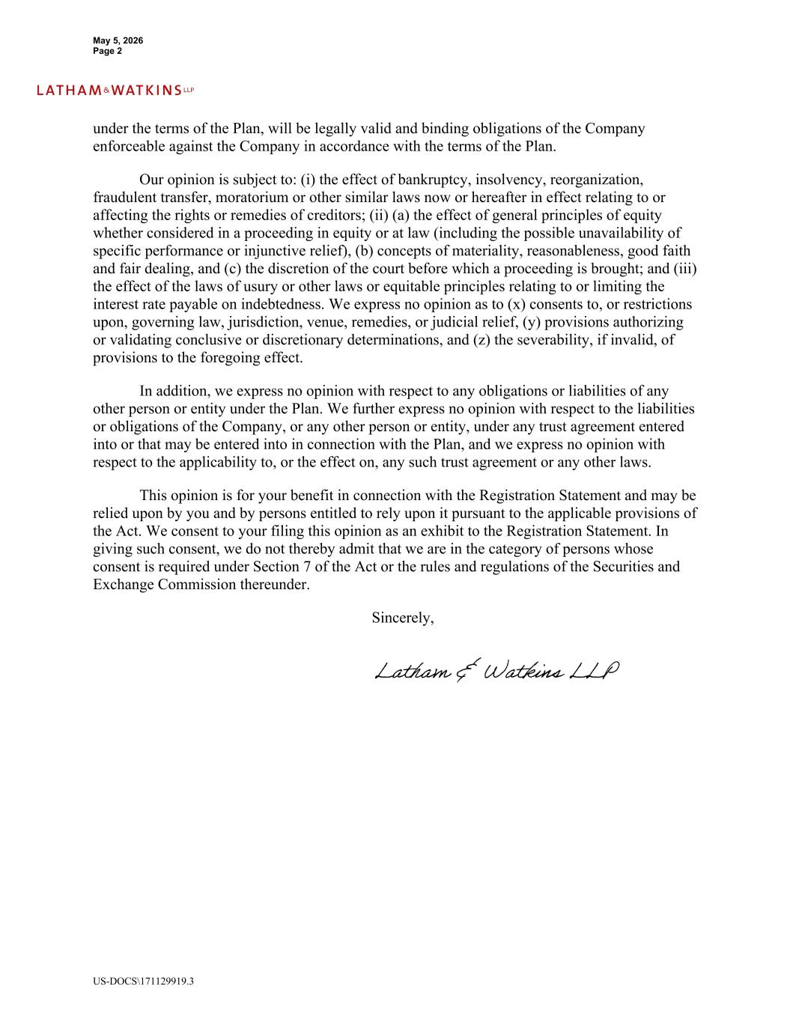
May 5, 2026 Page 2 US-DOCS\171129919.3 under the terms of the Plan, will be legally valid and binding obligations of the Company enforceable against the Company in accordance with the terms of the Plan. Our opinion is subject to: (i) the effect of bankruptcy, insolvency, reorganization, fraudulent transfer, moratorium or other similar laws now or hereafter in effect relating to or affecting the rights or remedies of creditors; (ii) (a) the effect of general principles of equity whether considered in a proceeding in equity or at law (including the possible unavailability of specific performance or injunctive relief), (b) concepts of materiality, reasonableness, good faith and fair dealing, and (c) the discretion of the court before which a proceeding is brought; and (iii) the effect of the laws of usury or other laws or equitable principles relating to or limiting the interest rate payable on indebtedness. We express no opinion as to (x) consents to, or restrictions upon, governing law, jurisdiction, venue, remedies, or judicial relief, (y) provisions authorizing or validating conclusive or discretionary determinations, and (z) the severability, if invalid, of provisions to the foregoing effect. In addition, we express no opinion with respect to any obligations or liabilities of any other person or entity under the Plan. We further express no opinion with respect to the liabilities or obligations of the Company, or any other person or entity, under any trust agreement entered into or that may be entered into in connection with the Plan, and we express no opinion with respect to the applicability to, or the effect on, any such trust agreement or any other laws. This opinion is for your benefit in connection with the Registration Statement and may be relied upon by you and by persons entitled to rely upon it pursuant to the applicable provisions of the Act. We consent to your filing this opinion as an exhibit to the Registration Statement. In giving such consent, we do not thereby admit that we are in the category of persons whose consent is required under Section 7 of the Act or the rules and regulations of the Securities and Exchange Commission thereunder. Sincerely,

Exhibit 23.1

Consent of Independent Registered Public Accounting Firm

We consent to the incorporation by reference in the Registration Statement (Form S-8) pertaining to the Rhythm Pharmaceuticals, Inc. Deferred Compensation Plan (Directors), of our report dated February 26, 2026, with respect to the consolidated financial statements of Rhythm Pharmaceuticals, Inc. and the effectiveness of internal control over financial reporting of Rhythm Pharmaceuticals, Inc. included in its Annual Report (Form 10-K) for the year ended December 31, 2025, filed with the Securities and Exchange Commission.

/s/ Ernst & Young LLP

Boston, Massachusetts
May 5, 2026

